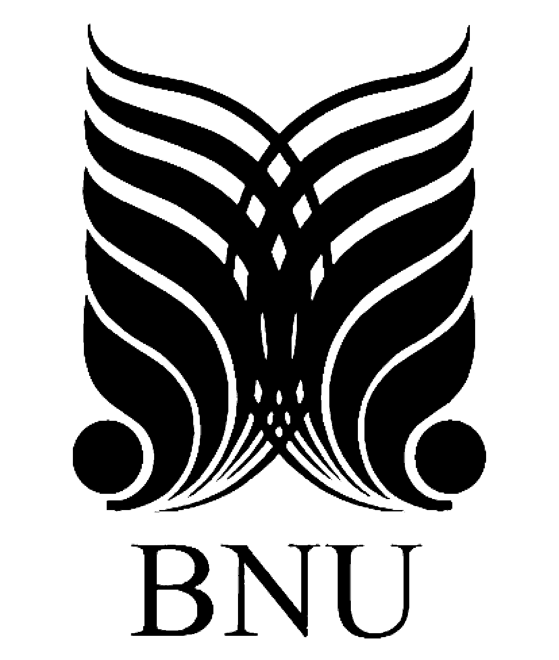
Saad Mughal | F2023-009
Sheikh Muhammad Ibrahim | F2023-630
Total Marks: 20
Due 13 December 2025

Digital Marketing

Project Deliverable

Course Lecturer: Nimra Abbas

Section: A

Digital Marketing (BUS-300) - Project Deliverable
SEO Optimization Report

Brand Name: The Slushbox Collection

URL
https://theslushboxcollection.threadless.com/

Screenshot
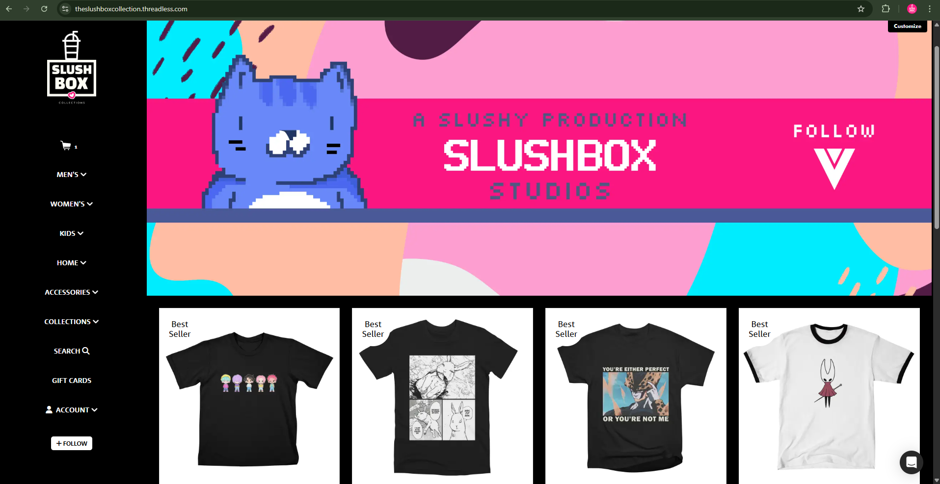

Best Seller #1

URL
https://theslushboxcollection.threadless.com/designs/saja-boys-chibi-k-pop-demon-hunters/kids/t-shirt

Screenshot
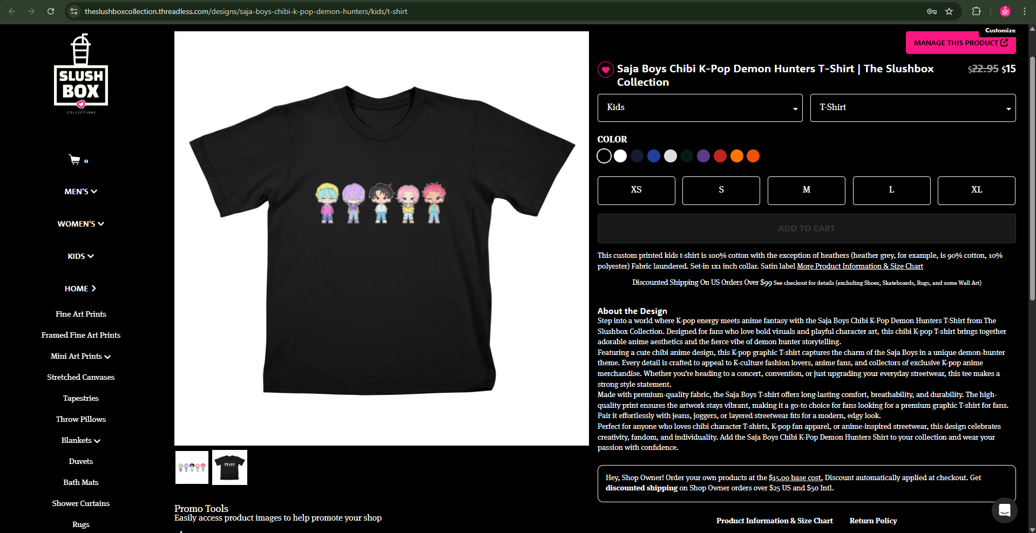

SEO Title
Saja Boys Chibi K-Pop Demon Hunters T-Shirt | The Slushbox Collection

Meta Description
Shop the Saja Boys Chibi K-Pop Demon Hunters T-Shirt from The Slushbox Collection. Cute chibi art meets K-pop style - perfect for anime and K-culture fans.

Focus Keypharse
Saja Boys T-Shirt

Keywords Used
Secondary / Supporting Keywords (Used):
- Chibi K-Pop T-Shirt
- K-Pop Demon Hunters Shirt
- The Slushbox Collection T-Shirt
- Anime K-Pop T-Shirt
- Chibi Anime Shirt
- K-Pop Graphic T-Shirt
- Cute Chibi T-Shirt
- K-Culture Fashion Tee
- Premium Graphic T-Shirt for Fans
LSI / Related Keywords:
- K-pop anime merchandise
- Demon hunter anime shirt
- K-pop fan apparel
- Chibi character T-shirt
- Streetwear K-pop T-shirt

Best Seller #2

URL
https://theslushboxcollection.threadless.com/designs/honored-bun-nah-id-win/mens/t-shirt/classic

Screenshot
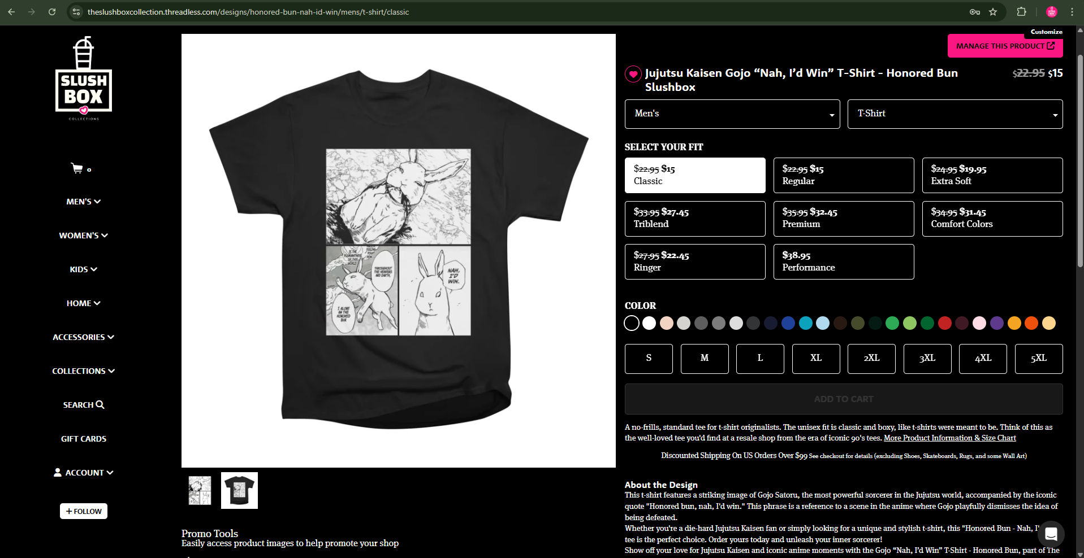

SEO Title
Jujutsu Kaisen Gojo “Nah, I’d Win” T-Shirt - Honored Bun Slushbox

Meta Description
Get the Jujutsu Kaisen Gojo “Nah, I’d Win” T-Shirt – Honored Bun from The Slushbox Collection. Featuring the iconic Gojo manga panel.

Focus Keypharse
Gojo Jujutsu Kaisen Shirt

Keywords Used

Secondary / Supporting Keywords (Used):
- Honored Bun T-Shirt
- Nah I’d Win Graphic Tee
- Anime-Inspired T-Shirt
- Jujutsu Kaisen Manga Panel Shirt
- Streetwear Anime T-Shirt
- The Slushbox Collection Tee

LSI / Related Keywords
- Gojo Satoru inspired T-shirt
- Jujutsu Kaisen fan merchandise
- Anime meme graphic tee
- Otaku fashion T-shirt
- Japanese anime streetwear

Best Seller #3

URL
https://theslushboxcollection.threadless.com/designs/youre-either-perfect-or-youre-not-me-perfect-cell/mens/t-shirt/classic

Screenshot
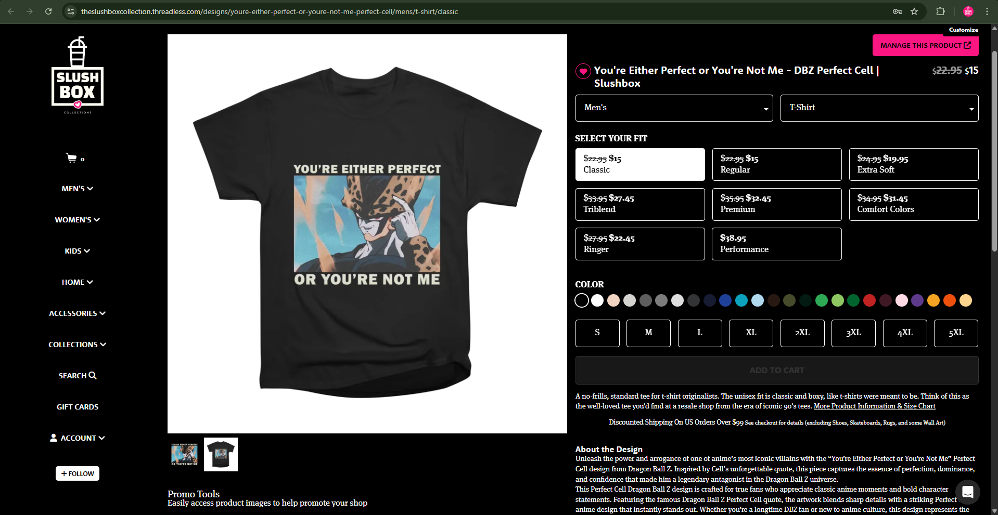

SEO Title
You're Either Perfect or You're Not Me - DBZ Perfect Cell | Slushbox

Meta Description
Unleash iconic anime energy with the “You're Either Perfect or You're Not Me” Perfect Cell design from Dragon Ball Z. Part of The Slushbox Collection.

Focus Keypharse
Perfect Cell Dragon Ball Z

Keywords Used
- You're Either Perfect or You're Not Me
- Dragon Ball Z Perfect Cell quote
- Perfect Cell anime merch
- Dragon Ball Z anime clothing
- DBZ villain merchandise
- Perfect Cell anime design
- Dragon Ball Z fan apparel
- Slushbox Collection anime
Long-Tail Keywords:
- You're Either Perfect or You're Not Me Perfect Cell shirt
- Dragon Ball Z Perfect Cell quote merchandise
- DBZ Perfect Cell anime apparel
- Iconic Dragon Ball Z villain quote
LSI / Supporting Keywords:
- anime streetwear
- Japanese anime merch
- classic Dragon Ball Z villains
- anime quote apparel

Best Seller #4

URL
https://theslushboxcollection.threadless.com/designs/chibi-crested-hollow-knight-silksong-cute-hornet-design/mens/t-shirt/ringer

Screenshot
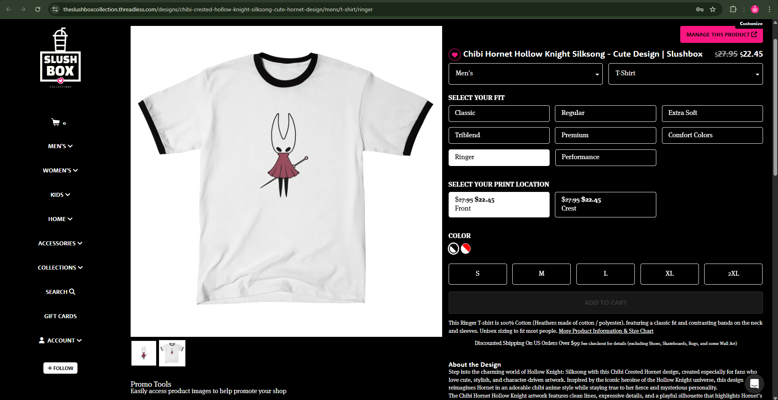

SEO Title
Chibi Hornet Hollow Knight Silksong - Cute Design | Slushbox

Meta Description
Celebrate Hollow Knight Silksong with this adorable chibi Hornet design. Cute, stylish, and part of The Slushbox Collection - perfect for fans of Hollow Knight and indie game art.

Focus Keypharse
Hollow Knight Silksong Hornet

Keywords Used
- Chibi Hornet Hollow Knight
- Hollow Knight Silksong merch
- Cute Hornet design
- Hollow Knight anime style
- Hornet Silksong artwork
- Indie game merch
- Hollow Knight fan apparel
- Slushbox Collection
Long-Tail Keywords:
- Chibi Hornet Hollow Knight Silksong design
- Cute Hollow Knight Silksong Hornet merch
- Hollow Knight Silksong chibi art
- Hornet Hollow Knight cute illustration
LSI / Supporting Keywords:
- indie game fan art
- cute gaming merchandise
- Hollow Knight character design
- minimalist chibi artwork

